Fig, Grape and Spinach Salad
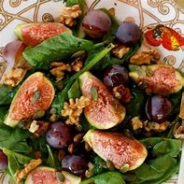

- 2 - 3 figs, quartered
- 12 (more or less) grapes, halved
- Spinach
- 1/4 cup walnuts
- 1/8 cup roasted pumpkin seeds or roasted squash seeds
- 3 tablespoons balsamic vinegar
- 3 tablespoons extra virgin olive oil
- 1/4 teaspoon salt
Instructions
- Mix the spinach, figs, grapes, squash seeds and walnuts in a bowl or on a salad plate.
- In a small bowl, whisk the balsamic vinegar, extra virgin olive oil and salt. Adjust the taste.
- Pour the dressing on the salad when ready to eat.

